**Social Media search**

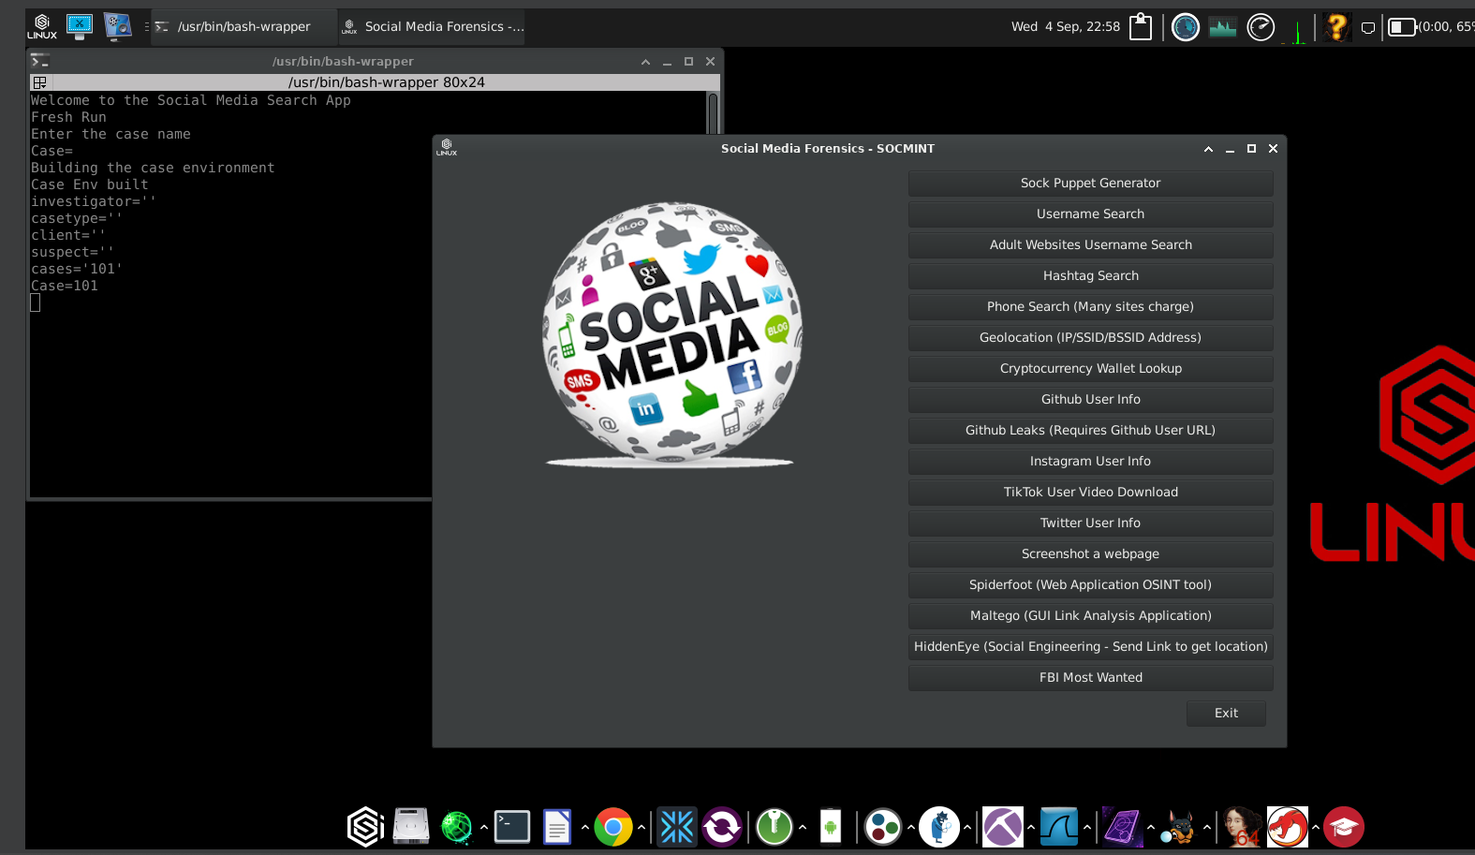

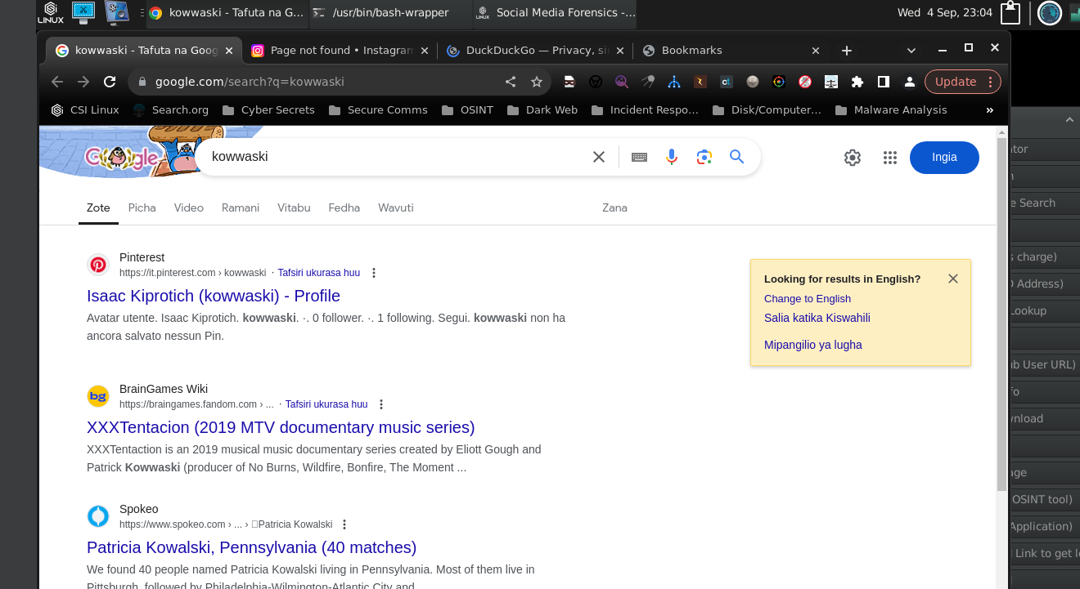

**Little Brother**

